Mathematics Syllabus
Teacher: Sharon H. Strachan
Website: http://mysticalmath.weebly.com
Remind Codes: ECM I @ strachecmp1
Math II @strachm2p2
ECM 4 @strachecmp4
Welcome to Math III and Math IV! The goal for this course is to prepare students for success in college, build upon mastered algebra concepts, develop problem solving skills, and understand practical applications of math in our everyday lives. To achieve this goal, we will utilize the following activities:

- Utilizing critical thinking skills
- Completing projects
- Using problem solving skills

- Focusing on math vocabulary identified in problems
- Working independently and/or groups

Grading Scale & Distribution

A 100-90
B 89-80
C 79-70
D 69-60
F 59 or below

Classroom Assignment Weight
Tests/Projects 50%
Quizzes 35%
Homework 15%

Required Supplies
- 1-inch binder
- Pencils (no pen for assignments)
- Highlighters/Markers/Colored Pencils
- College ruled loose-leaf paper
- Ti-83 or Ti-84 calculator

Participation/Assignments
Students are expected to work on warm-ups, take notes, complete assignments/activities/projects and ask/answer questions, and keep their notebooks organized.

OTTER
Silent Sustained Reading will occur the first 10 mins of each class period. The expectation is for students to spend this time actively reading a book of their interest. So, bring your favorite book with you each and every day! No worries, if you forget, I will have a few options for you to choose from in my room!

Warm-ups
Each day we will start with a warm-up during the first 15 minutes of class. They will range from topics covered the previous day, to review topics of necessary skills. These will be collected at the end of the week and work must be shown. These will be graded and entered as a minor assessment.

All hard copies of any paper handed out to students, can also be found on my website. Please familiarize yourself with this calendar, it is very useful for absences, review, organizing your notebook, etc.

Homework/Practice
Homework will be assigned most nights on that day’s material. Assignments will be reviewed in class the following day. The student must bring the completed assignment to class. This will be a formative assessment and so it will NOT be graded for accuracy. Students will receive feedback on their work. Indicators shown below must be present in order for an assignment (specifically homework) to be accepted.

- Written in composition notebook
- Name, date, and block are found in the upper right corner of the page
- Assignment page and problem numbers found on the title line
- Work neatly completed
  - Original Problems Copied (except word problems).
  - Work Shown (must have to be considered complete)
  - Answers Indicated (highlighted, circled, etc.)

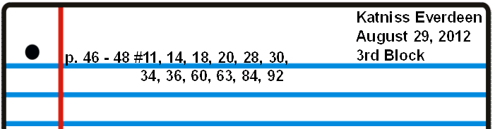

Homework/Practice Formative Grading Scale:

All homework is out of number of problems assigned:
- All problems are expected to be completed with work shown.
- Formative Assessment assignment, so homework will not be counted towards final grade.
- Quiz/Test rework will be accepted but only if all homework leading up to that quiz/test has been completed.

- Verbal Warning
- Conference with the teacher and/or phone call to parents
- Lunch Detention
- Period Detention
- Office/referral

- Be respectful!
- Be prompt!
- Be prepared daily!
- Be responsible!

Discipline Classroom Expectations and Rules

You are accountable for your own success!
Take every opportunity to learn as much as you can.

By signing below, you are indicating that you have read the syllabus and understand the rules and expectations set by Mrs. Strachan. *Note: The syllabus is tentative and can change at any point.

Signatures are due by Friday, August 18, 2017

______________________________________ ______________________________________
Student Signature Parent Signature

